County Councillor Update  Coker Division SCC  Cllr Mark Keating  June 2020 |  | 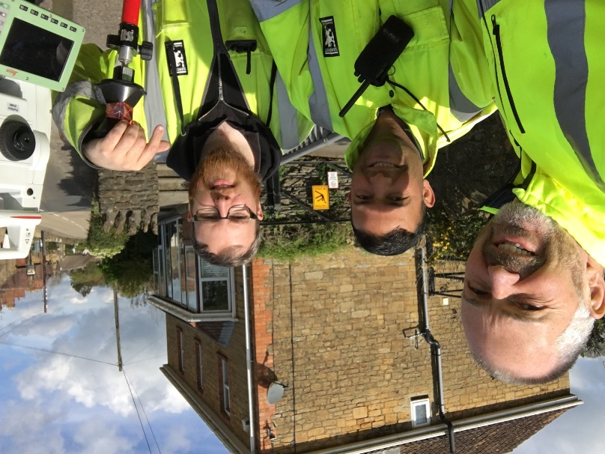
Representing you in - Barwick, Chiselborough, Closworth, East Chinnock, East Coker, Hardington Manderville, Hardington Marsh, Hardington Moor, Haselbury Plucknett, Middle Chinnock, Montacute, North Coker, North Perrott, Norton Sub Hamdon, ​Odcombe, Pendomer, Sutton Bingham, Stoford, West Chinnock, West Coker.
Useful Contacts Resources and Websites: Somerset Coronavirus Support Helpline: 0300 7906275
Cllr Mark Keating – Somerset County Council | E: MAKeating@Somerset.gov.uk | M: 07767 203968
South Somerset Area Highways Office | E: countyroads-southsom@somerset.gov.uk | T: 0300 123 2224
Report Pothole/Road Defect | E: roadsandtransportSD@somerset.gov.uk | T: 0300 123 2224
Report Dead Animal/Mud on Road | E: roadsandtransportSD@somerset.gov.uk | T: 0300 123 2224
Neil McWilliams – Highways Service Manager | E: countyroads-southsom@somerset.gov.uk | T: 0300 123 2224
Lee Norman/Derek Davies – Assist Highways Service Manager | E: countyroads-southsom@somerset.gov.uk | T: 0300 123 2224
Garry Warren/Rebecca Vaughan – Traffic Engineer. Traffic & Transport Development | E: countyroads-southsom@somerset.gov.uk | T: 0300 123 2224
Gully Emptying / Road Sweeper | E: chris.holley@southsomerset.gov.uk | T: 01935 462462
Nick Allen – SSDC Ranger Scheme | E: nick.allen@southsomerset.gov.uk | T: 01935 462462
Road Records & Highway Licensing | E: Roadrecords@Somerset.gov.uk | T: 0300 123 2224

Report Adult at Risk | adults@somerset.gov.uk |  |  | T: 0300 123 2224  T: Emergency: 999
Report Child at Risk | childrens@somerset.gov.uk |  |  | T: 0300 123 2224  T: Emergency: 999
Children’s Social Care Worker out of hours Emergency Duty Team |  |  |  | T: 0300 123 2327
Fostering and Adoption www.fosteradoptsomerset.org.uk | AandFRecruitmentEnquiryLine@somerset.gov.uk |  |  | T: 0800 587 9900
www.somersetwaste.gov.uk |  | ssdc@southsomerset.gov.uk | T: 01935 462462
https://www.travelsomerset.co.uk/ |  | Travel - Drive Bus Train Walk Cycle Weather
www.somerset.gov.uk |  | generalenquiries@somerset.gov.uk | T: 0300 123 2224
http://roadworks.org/ |  | Useful website for road works info
www.facebook.com/somersetcountycouncil |  | Somerset County Council Facebook page
https://roam.somerset.gov.uk/roam/map |  | Interactive Rights of Way Map / maintenance reporting

Corona Virus Update: Whilst every death is undoubtedly an absolute tragedy, the situation in Somerset has been throughout the pandemic relatively quiet compared to the rest of the Country. As at 26th June, the number of confirmed Covid cases in Somerset was 795 and the number of Covid-attributed deaths 195. At 0.6, the R Value for the South West was the lowest of all English regions, with the national average being 0.7-1.0. Of Somerset’s 200 Care Homes, only one currently has any Covid19 cases within it.

Outbreak Management Plan: Somerset’s Outbreak Management Plan has been developed, agreed and will shortly be posted onto the SCC website. The Plan outlines the measure in place and the actions which will be taken should a local outbreak of Covid19 occur in the County including Test and Trace. Public Health England rated Somerset’s plan as exemplary and it will be used as a benchmark nationally.
SCC Financial outcome for 2019/20: Positive financial results and a major boost to reserves have put Somerset County Council in a strong position. In the last financial year, SCC increased its reserves to £76.2m across the board and delivered efficiencies that enabled a £6.4m underspend on the total budget.
SCC Covid19 Finances: SCC estimates additional costs of around £47m to help communities deal with coronavirus. To date the NHS Clinical Commissioning Group have reimbursed approx.. £6 million and the Government have allocated an additional £26m to Somerset. It is expected that a further Government award to help close the small shortfall will be made shortly. Major expenditure has included: Paying a 10% increase to all care home providers to help them stay financially viable through the crisis – £3.1m; Personal Protective Equipment (PPE) – Government provides just 22% of the PPE required by schools, nurseries and key workers in Somerset, Somerset County Council is funding the remaining 78% – predicted cost £6m; Setting up and running a new care homes in Yeovil– £1m each; Supporting nurseries and childcare settings to enable them to financially survive – £2.1m; Running social care services seven days a week – £1m; Supporting District Councils with additional homelessness costs – £0.8; Supporting our supply chain on major building projects – £2.3m. Plus a whole host of other costs that add up!
Ilminster/Crewkerne Area Schools Review: A review into the future of the current school system in Ilminster and Crewkerne will restart, after Somerset County Council won a key legal battle last week. Since 2018, the Council has been working with headteachers and governors of schools in the area to review the education provision, which includes Swanmead Middle School, as the current three tier structure is not viable given the number of pupils in the area.
A decision by the South West Regional Schools Commissioner (RSC) last autumn, to allow Swanmead to become an academy brought the review to a halt. The Council raised its concerns about this decision with the Regional and National Schools Commissioners but they declined to alter their position. As a result, it was necessary to issue proceedings in the High Court to challenge the RSC’s decision through a Judicial Review. The Council participated a two-day trial before Mr Justice Fraser earlier this month. He ruled that the Regional Schools Commissioner’s decision for Swanmead to become an academy was unlawful and should be quashed, upholding the Council’s position.
We need to have a school structure in place that is sustainable in the long term and that provides high quality education for the children and young people in our area. We recognise there will be a period of uncertainty for children and families until a decision is made, but it is important that the review is as thorough as it can be, and that proper process is followed. Keeping things as they are is simply not an option. We will keep changes to a minimum but where changes are necessary, there will be detailed consultation with parents and carers, staff, children and anyone else who may have an interest. We will work closely with head teachers, governors and the RSC to ensure that any change is well-managed and meets the needs of children.
Armed Forces Day in Somerset: The flag to honour the Armed Forces in Somerset was raised on Monday 22 June by Somerset County Council Chair Councillor Nigel Taylor outside County Hall in Taunton. He was joined – with social distancing observed – by Council Leader David Fothergill, Councillor Rod Williams, who chairs the Somerset Armed Forces Covenant Partnership and Council Chief Executive Pat Flaherty.
Climate Change: SCC have become founding Members of a new network which been established by UK100 to campaign on climate change. The 21 councils involved in the Network represent 14.3 million people in total, a quarter of the population (25%) and two fifths (41%) of England by area. The network is to focus on rural communities who face unfair barriers in trying to decarbonise – it is often harder to attract funding for projects which don’t fit traditional cost benefit analyses and which often favour urban concentrations with less overall carbon reduction impact.
One Somerset: The business case to move to a Single Unitary authority across Somerset will be available on www.onesomerset.org.uk from 7th July and will cover in detail the reasons for the recommendations and the substantial benefits to the residents of Somerset. The business case will pass through SCC’s Scrutiny Panel and Cabinet before being considered at Full Council on the 29th July. Engagement and consultation activities will continue through July and into the Summer.
Registration Services: Birth registrations are now making a phased return in Somerset following the gradual easing of coronavirus restrictions. The service, run by Somerset County Council, had to be put on hold in March at the start of the nationwide pandemic lockdown due to Government instructions but now parents can book appointments to register the birth of babies born before 31 March 2020. The number of appointments will be limited at first, as safety measures must be put in place in buildings to protect the public and members of the registration service staff. With the service suspended for many weeks, there is a large number of births to be registered and parents of babies born after 1 April are asked to stay patient for now until more offices are open. Further updates will follow – please check www.somerset.gov.uk/births-ceremonies-and-deaths/register-birth
Library Services: Somerset Libraries are planning the phased re-opening of library buildings with the aim to start welcoming people back in July.
It won’t be business as usual straight away, however, and Somerset County Council’s library buildings will look and feel quite different, as some processes temporarily change. Social distancing measures will be in place and a ‘personal shopper’ service will be available as customers will not initially be able to browse. Staff will be available to select items for customers based on popular titles, specific interests and favourite authors. Full details of which libraries are planned to open and when that’s finalised will be available soon via the Somerset Libraries website (www.somersetlibraries.co.uk) Importantly there will be no overdue charges as a result of items borrowed just before buildings closed on the 19th March due to COVID-19!
Commonplace: A new interactive online mapping tool has been launched to enable members of the community to flag up areas of concern in a specific area where changes to walking, cycling and travel could make a positive difference. This work aimed at building on a number of temporary measures, including pedestrianised high streets which have already been introduced to encourage social distancing and positively support the safe movement of pedestrians and cyclists. The map can be accessed at https://somersetcovidactivetravel.commonplace.is/. An indicative figure of £482,000 for Somerset has also been published from the second tranche of funding where further new schemes will be considered.

